**Code & Output:**

import javafx.application.Application;

import javafx.scene.Scene;

import javafx.scene.canvas.Canvas;

import javafx.scene.canvas.GraphicsContext;

import javafx.scene.layout.StackPane;

import javafx.scene.paint.Color;

import javafx.scene.shape.ArcType;

import javafx.stage.Stage;

public class DrawShapesOnCanvas extends Application {

@Override

public void start(Stage primaryStage) {

primaryStage.setTitle("Draw Shapes on Canvas");

// Create a canvas

Canvas canvas = new Canvas(400, 400);

GraphicsContext gc = canvas.getGraphicsContext2D();

// Draw shapes and graphics

gc.setFill(Color.RED);

gc.setStroke(Color.BLUE);

gc.setLineWidth(2);

// Draw a rectangle

gc.fillRect(50, 50, 100, 100);

gc.strokeRect(50, 50, 100, 100);

// Draw an ellipse

gc.setFill(Color.GREEN);

gc.fillOval(200, 50, 100, 80);

// Draw a line

gc.setStroke(Color.BLACK);

gc.strokeLine(50, 200, 250, 200);

// Draw a circle

gc.setFill(Color.ORANGE);

gc.fillOval(50, 250, 80, 80);

// Draw an arc

gc.setFill(Color.PURPLE);

gc.fillArc(200, 250, 100, 100, 45, 270, ArcType.ROUND);

StackPane root = new StackPane();

root.getChildren().add(canvas);

primaryStage.setScene(new Scene(root, 400, 400));

primaryStage.show();

}

public static void main(String[] args) {

launch(args);

}

}

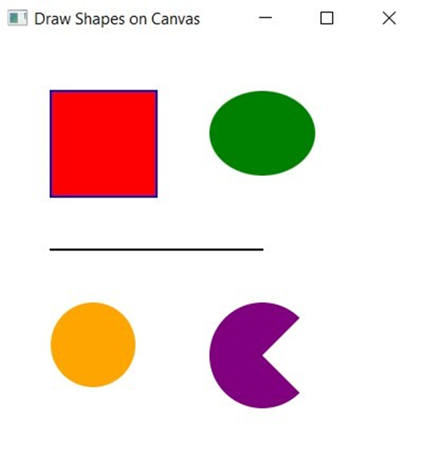

**Conclusion:** Thus, we created a FX design and executed the program successfully.